RF Conditioning

Dark current too set-up

Data traces, fine, 100 Hz vac spike, data a concern, can we respond faster?

Data analysis, how many false positives due to flat traces(power off) were there?? Or outside mask,

Is it really better to use phases for masks?

Need to write down the flow of the programme, as-is,

LRRG: we will only have CRP, check phase on breakdown

Create separate, LRRG config file

Abstract

This programme is an automatic RF conditioning script that is designed to ramp the RF power following a defined ramp curve whilst also staying below a desired breakdown rate. On detecting a breakdown it is designed to switch off the RF power before the next RF pulse and record various datasets for further analysis. The programme is designed to be agnostic with respect to which of VELA/CLARA’s RF structures is being conditioned, but particular effort has been applied to the high –repetition rate photo-injectors cavity.

Introduction.

Here, in general terms, are the main experimental goals: [1]

The aim of the programme is to condition the cavities to accept the highest gradient RF field. This is done by ramping up the RF gradient maintaining the breakdown rate below some level (for example ~ 5 breakdowns per 105 RF pulses). On detection of a breakdown (or more generally an event) the power is momentarily disabled while the cavity recovers. Generally, events should be detected in the RF power traces and the power switched off before the next pulse. If the breakdown rate is too high the RF power is reduced until the breakdown rate falls below the required value.

A steady vacuum level should be maintained in the cavity. Excessive breakdowns can cause power to be concentrated in local hotspots causing matter to be ejected into the system, ‘*a vacuum spike*’. This matter can redistribute itself in an undesirable manner and/or damage surfaces such as the photo-cathode and cavity effecting future performance and dark current levels. It is hoped that disabling the RF power before the next RF pulse will help mitigate these vacuum events.

Good quality coherent data should also be saved. This includes a running log of the state of the main parameters and a ‘data dump’ that is event driven. The data dump includes the RF power traces and other ancillary data. These traces form the basis of the experimental data.

RF traces

The RF amplitude and phase is monitored in up to five places:

Klystron forward and reverse

Cavity forward and reverse

Cavity probe (not always available)

What is a breakdown? What is a Mask?

For the purposes of this programme a breakdown occurs when a trace falls outside a defined mask. The mask is defined based on previous good traces at that power and pulse length. [ref]. typically masks have high and low values derived from an absolute or percentage difference of previous values of the trace. Figure 1 shows example traces and mask. (more detail about the mask is given later)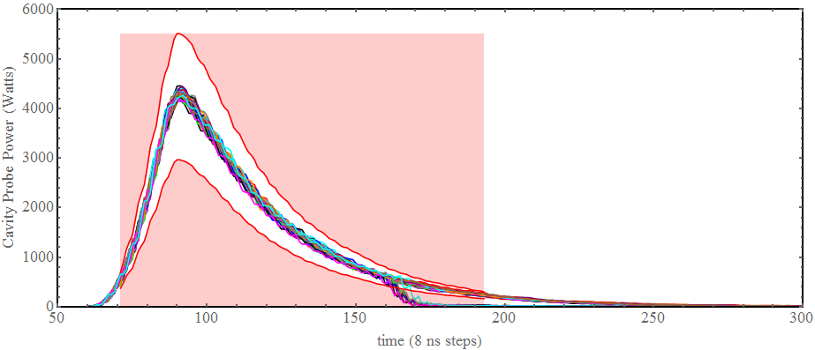

Figure 1: example cavity probe traces with mask(red area). Outside mask traces can clearly be seen at ~170 time steps.

collection of classes that perform three main tasks, data collection and simple processing, via monitoring EPICS signals all managed by controller classes.

Concepts

Configuration File

On starting the application a config file is read. This sets some of the main required parameters options. Discussed later.

Pulse - breakdown log file

The programme has a ‘memory’ of the conditioning history contained in ‘*pulse_breakdown_log.txt*’ this enables the number of active pulses, breakdown rate, position on the rf power ramp curve and the pulse length to be carried over from day-to-day. It can be hacked to manually change the conditioning state.

Data-log

Periodically (as defined in the config but usually every second) the current state of the data is written to file as binary data (for reasons of speed & file-size). Each file contains a plaintext header so that the type of each byte can be interpreted and an example Mathematica notebook is provided to give hints on how to read the file.

Log.txt

As the programme runs a plaintext log file is kept that updates with messages from the various monitors and controllers. This log file is to help with debugging issues and to be able to check the input parameters when analysing the other data-logs.

Pickle-Dumps

When an event occurs a dictionary of data is collected, these include trace history before and after the event, and other parameters, i.e. the trace that caused the event, the masks, vacuum level etc. Two types of event are distinguished: an outside mask event and a spike event. For outside mask events the number of extra traces to save after the event is specified in the config file. On a spike vent the entire trace history buffer, with the number of traces defined in the config. The dictionaries are written to file as a pickle-dump, a binary format that makes them easy to re-read into python but more difficult to export as non-python.

Signal Data

All the data from the monitored signals is held in a single, static, dictionary, called data.values. This dictionary is available to all classes through inheritance or reference. All classes can then update or read the latest data values. As well as signal values data.values holds derived data, such the state of the vacuum, the state of the dark current, i.e. is the vacuum ‘*good*’ or ‘*bad*’

Spike Monitor

Example uses, vacuum and dark current spike monitors

An abstract class that can take a signal and keep a moving average.

If the next signal value ‘*spikes’* (i.e. is a specified level above the current mean) then then the object status goes ‘*bad.*’ The status returns to ‘*good’* via one of two modes: after a specified time in ‘*timed* ‘ mode or when the signal value returns to a certain level expressed as a factor of the current mean. When the status is ‘*bad*’ updating the rolling mean is disabled. To allow for the quickest response time to switch off the RF power a spike monitor also has flag to ‘drop amplitude to zero’ if set this will change the amplitude to the requested value on spike detection.

The ‘status’ and the ‘value’ of the signal are updated in the data.values via keys passed during construction

Value Monitor

A value monitor uses the c++ general_monitor to monitor a signal and write its current value to the passed data.values key

Active Pulses

Breakdown rates are defined in terms of the number of pulses, this requires a counter of the RF pulses that have power in them. An active power level, set in the config file and typically 1000 W, is used along with the klystron forward power trace to define an active pulse. If at least one value in the trace is above the active power level the rf pulse is defined as *active* and the pulse count is increased and other checks (such as checking mask s) are carried out. The number of active pulses is carried over by using the value form the pulse_breakdown_log.

Ramping

To maintain a steady increase in terms of watts / active pulse and to allow for variable step sizes the ramp is pre0defined in a look-up table. This gives the power step in watts and the number of active pulses required to make the next step.

Mask Details

Steep raising and falling edges in the trace can cause issues as the jitter at these points can lead to spurious fails. These steep edges

DATA

CONFIG READER

DATA

LOGGERR

BASE

MONITOR

GUI

MAIN

CONTROLLER

C++ HARDWARE CONTROLLERS

|  |  |
| --- | --- |
| DATA | Holds a dictionary with all the single value data, i.e. current vacuum level, cavity reverse power, DC state. This dictionary is accessed by all other classes to update / read latest values  Has a timer that writes the data_log.dat file |
| CONFIG READER | Reads the config file and puts the input data into a series of dictionaries, for example all the vacuum monitor settings are held in the ‘vac_param’ dictionary. These dictionaries are then available to all other classes |
| DATA  LOGGERR | Knows how to read and write all files associated with the application, ***APART from*** the ‘config file’. Has a messaging function. Messages can be written to stdout and also to a txt file |
| C++ HARDWARE  CONTROLLERS | c++ hardware controllers, for: LLRF, vacuum valves, RF modulator, RF protection, |
| BASE | A utility class to hold all the lower level classes in one place and acts as a single point of contact for the higher-level classes.  Is also a good place to put general functions that can be used in higher level classes |
| GUI | The GUI classes are derived from a QTDesigner file that is then inherited by the top level class, gui_conditioning.  To make updating the GUI values easy output widgets are held in a dictionary with the same keys as the data.values dictionary. The gui has an update timer that refreshes the gui widgets |
| DATA  MONITOR | The data monitor class hold a series monitor classes. These include abstract monitors such as Spike Monitors and value monitors, and specific hardware monitors such as vacuum valve, rf protection and modulator monitors. Also has a c++ general monitor object that is used to monitor values that do not require control (water temperatures, etc.)  In principal, (but not yet in practice) the monitors are also able to control the hardware. For example, The modulator monitor could reset the modulator after a trip. |
| MAIN  CONTROLLER | This class holds all the objects, and controls the flow of the programme. After all objects are instantiated, signals connected, monitoring started and data is being updated the main controller enters the main event lop. This decides how to ramp up and down the RF |

1. ‘ADVANCES IN HIGH-GRADIENT ACCELERATING STRUCTURES AND IN THE UNDERSTANDING GRADIENT LIMITS’ W. Wuensch, CERN, IPAC 2017